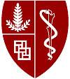

**Clinician Educator – Interventional Cardiologist**

**Division of Cardiovascular Medicine, Department of Medicine**

**Stanford University, School of Medicine**

The Department of Medicine, Division of Cardiovascular Medicine, at Stanford Medicine is seeking a board certified/eligible interventional cardiologist in the Clinician Educator line to grow the structural heart and coronary interventional cardiology program. This physician will be based at Stanford Health Care in Palo Alto, as well as in its outreach clinics in the greater Bay Area.

Successful candidates will be expected to teach medical students, residents and fellows in the clinical setting. Candidates with experience and interest in transcatheter structural heart disease treatment are preferred. The ranks of Clinical Professor, Clinical Associate Professor, or Clinical Assistant Professor, will be based on training and experience.

The major criterion for appointment, reappointment and promotion for Clinician Educators is excellence in the overall mix of clinical care and clinical teaching appropriate to the programmatic need the individual is expected to fulfill.

Submit CV and a brief letter of interest to the Director of Interventional Cardiology, Dr. William Fearon at: <http://facultyapplication.stanford.edu>

*Stanford is an equal employment opportunity and affirmative action employer. All qualified applicants will receive consideration for employment without regard to race, color, religion, sex, sexual orientation, gender identity, national origin, disability, protected veteran status, or any other characteristic protected by law. Stanford also welcomes applications from others who would bring additional dimensions to the University’s research, teaching and clinical missions.*

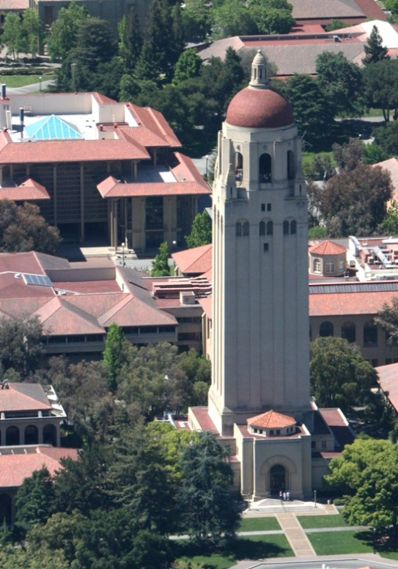

*Stanford University is an equal opportunity employer and is committed to increasing the diversity of its faculty. It welcomes nominations of and applications from women and members of minority groups, as well as others who would bring additional dimensions to the university's research, teaching and clinical missions.*

**Hoover Tower – Stanford University**